JetRacer Soccer League with Advanced Sensor Suite

Arjun Simha, Casey Rittenhouse, Cooper Ritter, K Gupta, Jarod Marshel, Julie Ham, Mason Kang

# Table of Contents

Table of Contents 1

Introduction/Abstract 2

Teams, Roles and Responsibilities 3

Team Contributions 3

Winter Project Schedule 4

Project Success Criteria 5

Spring Quarter Work 5

Spring Quarter Tasks: 6

Spring Project Schedule 6

System Requirements 6

Hardware/Software Design 7

Planned Primary Implementation 7

Mechanical Design 10

Design Procedure/Methods 12

Test Design 16

Realistic Constraints/Relevant Engineering Standards 16

Project Resources/Budget 17

Cost Breakdown 17

Industry Sponsor Comments 18

Success Criteria 18

# Introduction/Abstract

In its third year, the JetRacer Soccer League ENGINE capstone continues its goal of achieving autonomous 2v2 soccer using NVIDIA JetRacer cars with an advanced sensor suite. This year's goal is to implement new sensors to improve the car's capabilities and level of play. The project progresses as follows: demonstrate shooting on an open goal, 1v1 soccer with offense and defense strategies, and finally 2v2 soccer with collaboration.

# Teams, Roles and Responsibilities

* Project Manager: Jarod Marshel
* Point of Contact: Arjun Simha
* Budget Manager: Casey Rittenhouse
* ROS Team: Cooper Ritter, Casey Rittenhouse
* Sensors Team: Jarod Marshel, Arjun Simha
* Unity Team: Mason Kang
* CV/Image Recognition Team: K Gupta, Julie Ham
* Industry Mentors: Dalton Smith, Pete Sulcs, and James Waltner
* Faculty Mentor: John Raiti

## Team Contributions

Jarod Marshel – Team lead. Developed and tested LiDAR sensor and integrated with ROS on the Jetson Nano to test capabilities. Constructed a new field for the Jet =Racer cars to play soccer in.

Arjun Simha – Point of Contact. Developed and tested LiDAR sensor and integrated with ROS on the Jetson Nano to test capabilities. Helped integrate object tracking on ZED2. Managed contact and scheduled meetings with external stakeholders.

Casey Rittenhouse – Budget manager. Determined the optimal ROS distribution to complete goals. Established Jetson Nano VNC connection. Worked with Cooper to create ROS structure. Created ROS launch file to improve ease of use. Created a trade study to determine the best sensor to add to the car. Created Pugh matrix to assess and weigh options. Created structure to convert CV output to the correct format and send appropriate motor and servo messages. Created and tested ball tracking and following using ROS Melodic and the previous year’s CV model.

Cooper Ritter

Setup - Flashed Jetson Nano SD cards with Ubuntu 18 and set up GNOME VNC servers. Configured ROS Melodic environment and catkin workspace. Created an Excel spreadsheet with detailed instructions for setting up ROS and VNC on other cars.

ROS - Created a custom navigation package. Created subscriber to use NVIDIA_Racecar and Racecar scripts to control hardware using custom nav_topic containing steering angle, throttle percent, and camera angle data. Developed keyboard tele-op publisher to control cars using keyboard input. Developed a proportional controller for ZED2 camera servo and steering servo ball tracking using CV bounding box error data published in a text file.

Physical - Designed 3D models for car design including new chassis, servo mount, and ZED2 camera mount. Designed brackets for the soccer field. Used Altium Designer for schematic capture and created component footprint in case of future PCB development. Repaired broken RC cars and fixed throttle stalling errors caused by incorrect receiver and battery settings.

K Gupta – Implemented and debugged object detection and object following onto the Jetson Nano for both the ZED2 and CSI cameras.

Julie Ham – Implemented and debugged object detection and object following onto the Jetson Nano for both the ZED2 and CSI cameras.

Mason Kang – Set up the Unity Simulation for 2v2 and 4v4 fields and extracted the data for the potential integration of the environment. Created the 3rd year GitHub page for documentation.

# Project Schedule

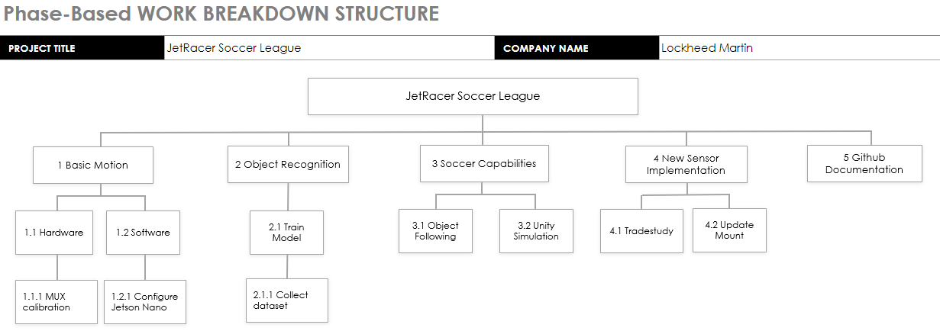  
Figure 1: Work Breakdown Structure

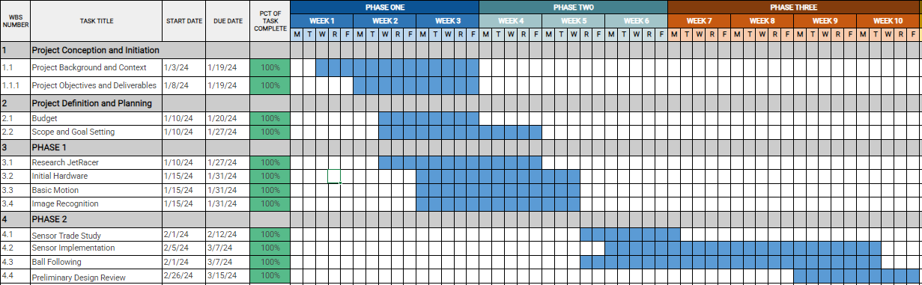Figure 2: Winter Quarter Gantt Chart

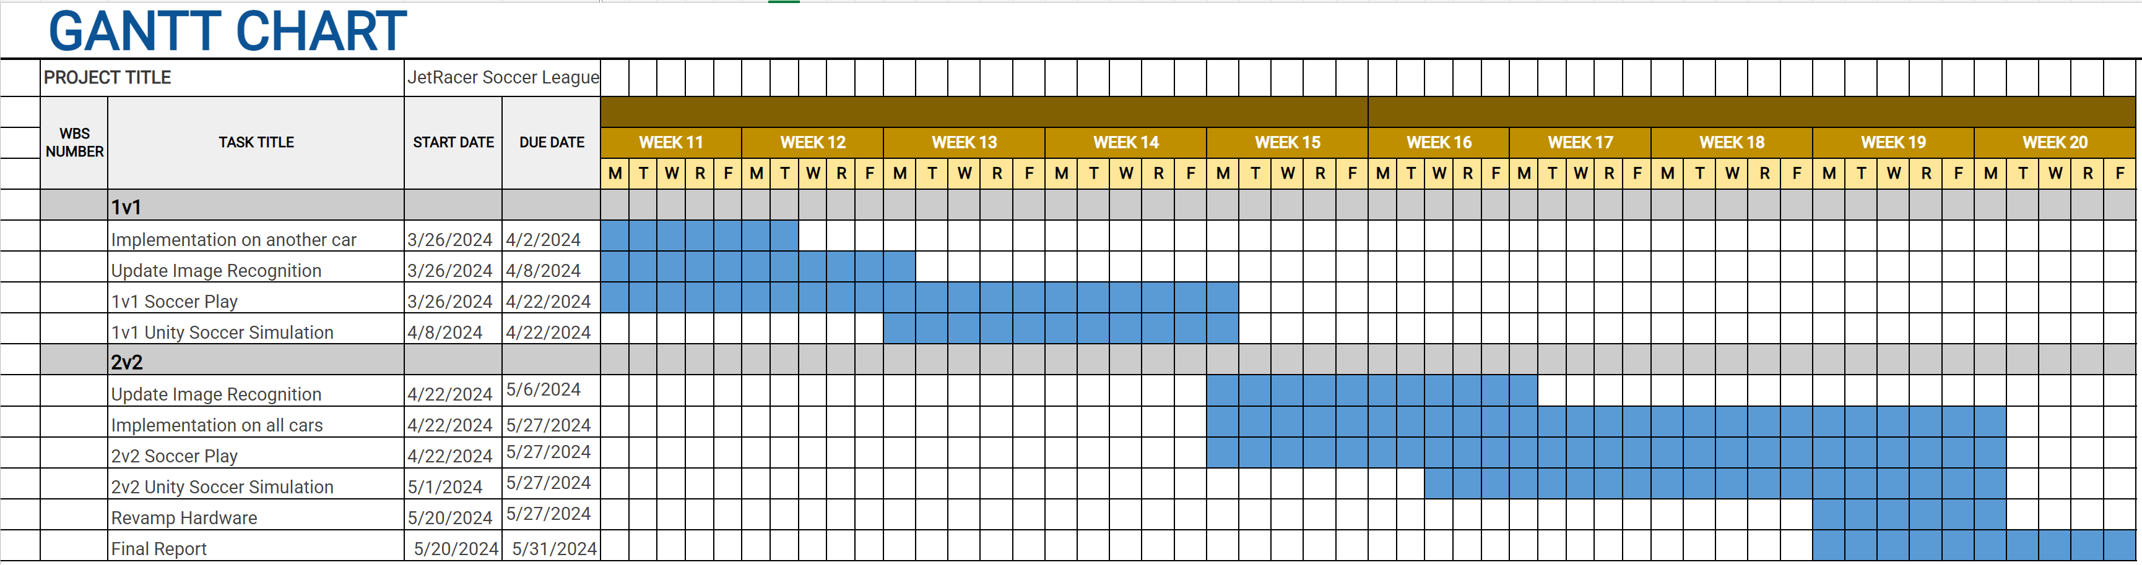Figure 3: Spring Quarter Gantt Chart

No changes have been made since the initial Project Plan. We completed the goals set for the winter quarter, successfully achieving basic motion, sensor implementation, and ball following with the new sensor chosen in the sensor trade study, the ZED2 stereo camera. For the spring quarter, our primary goal is to demonstrate 2v2 soccer capabilities. This means further developing capabilities with the integrated ZED2.

Spring Quarter Tasks:

* Train new YOLOv8 dataset: soccer ball, goals, other cars
* Migrate previous work to Ubuntu 20.04 and ROS Noetic
* Setup other cars: purchase three more ZED2s, 3D printed mounts, ROS Environment Setup
* Implement camera servo PID for soccer ball tracking
* Decrease ZED2 object detection latency
* Determine the necessity of upgrading to Jetson Orin Nano
* Demonstrate path planning to score on an open goal
* Explore Unity integration with the ZED2 pipeline
* Demonstrate 1v1 soccer with defense and offense strategies
* Demonstrate 2v2 soccer with collaboration

# System Requirements

1. Four JetRacers shall be built and maintained to meet the listed requirements.
2. The JetRacer(s) shall operate autonomously with the capability to manually override with a standard RC transmitter.
3. The JetRacer(s) shall demonstrate the ability to score a goal with the designed equipment autonomously.
   1. JetRacers should be able to switch between offense and defense according to current situation
4. The JetRacer(s) shall not pick up the ball.
5. The JetRacer(s) shall move the ball by striking it.
6. The JetRacer(s) shall be able to strike the ball in a controlled trajectory.
   1. The JetRacer(s) should be able to locate the ball without driving in circles.
7. The official game ball shall be a size 1 soccer ball.
8. The size of the soccer field shall be 20’ ft (L) x 15’ (W), with +/- 1 ft tolerance in each direction.
9. The soccer field shall be transportable.
10. The JetRacer(s) shall identify and work cooperatively with an ally (marking distinction determined by students) to score a goal.
11. The JetRacer(s) shall identify and work against an enemy (marking distinction determined by students) trying to score in the opposite goal.
12. The allies and foes in the JetRacer Soccer League shall be visually distinguishable.
13. There shall not be an overhead camera used for this work. The individual vehicle feeds shall be used to dictate their action.

# Hardware/Software Design

## Planned Primary Implementation

We will integrate the ZED2 AI stereo camera with the NVIDIA Jetracer RC car to accomplish 2v2 soccer. Streamlined communication between processes and hardware abstraction will be achieved using a ROS Noetic environment on the NVIDIA Jetson Nano 4GB. The Nano's OS must be upgraded to Ubuntu 20.04 with native Python 3.6.

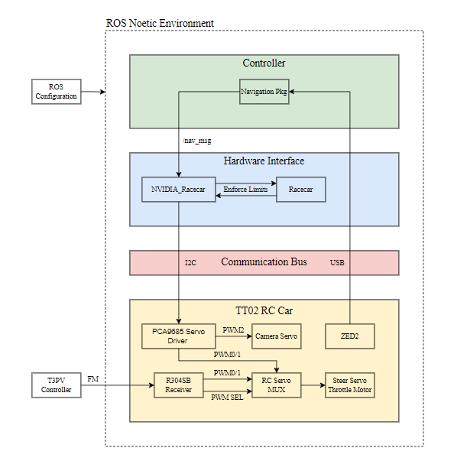

Figure 4: ROS Configuration

The top-level controller within the ROS environment will be a custom navigation package containing the ZED2 ROS wrapper. Using the ZED2 camera stream and IMU data, the controller will determine strategy and trajectory.

The ZED2 ROS wrapper allows the ROS environment to start up and communicate with processes outside of the environment. YOLOv8 will use pre-trained weights for object detection of the soccer ball, goals, and other cars. For increased efficiency, we will train a new dataset classifying only required objects within the real-world soccer field environment. This will be done by recording footage and tagging objects within the images. Once implemented, YOLOv8 will create a 2D bounding box with certainty measurement over detected objects. The corner coordinates of these boxes will be published on the zed_interface/BoundingBox2DF topic for comparison with the spatial map in the trajectory strategy. For soccer ball tracking, the distance in pixels from the center of the ZED2 FOV versus the center of the bounding box will be published to the Camera PID for error correction.

Using the car's URDF and initial pose, a spatial map is constructed. The point cloud is published over the mapping/fused_cloud topic for comparison with object detection for distance measurements. This information will be processed by the trajectory strategy to determine objectives and routes. Preliminarily, the car will flip-flop between offense and defense with predetermined routes. At the later stage, this data will be used in the ZED2 Unity pipeline to communicate with a pre-trained 2v2 ML model for decision-making. As the car moves, the spatial mapping process uses IMU data for positional tracking and relocalization, feedback which will be used for trajectory adjustment.

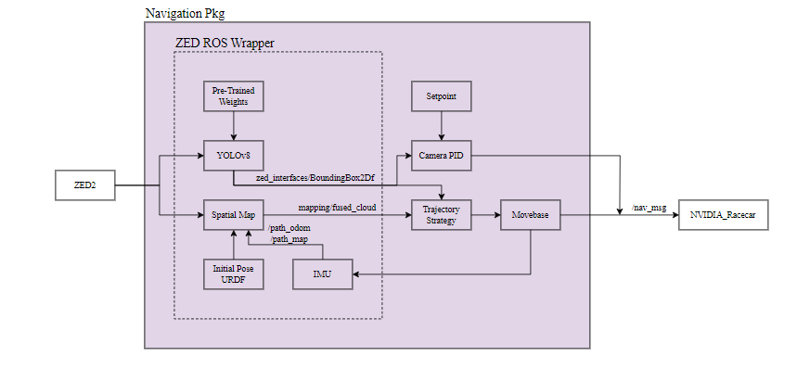

Figure 5: ROS Navigation Package

The Tamiya TT02 RC car hardware includes a brushed 540-type motor (throttle), Futaba S3004 servo (steering), and Miuzei 20kg servo (camera). The brushed motor drives the 4WD chassis up to 30 mph. The S3004 servo controls the steering of the front two wheels, with a range of 60 degrees. The Miuzei camera servo swivels to track the soccer ball, ensuring cars don't lose sight.

The NVIDIA_Racecar and Racecar scripts on the Jetson Nano use the PCA9685 Adafruit 16-Channel Servo Driver to control the car’s hardware. I2C communication between the modules is handled by the Adafruit CircuitPython-ServoKit library. The Pololu 4-Channel RC Servo Multiplexer switches hardware control between the remote and Jetson Nano, per system requirement two. The ZED2 is connected to the Jetson Nano via USB.

Figure 6: Electrical Schematic

To mount the ZED2, we designed new 3D printed parts: chassis, servo mount, and camera mount. The models were designed in Autodesk Inventor Professional and printed on a MakerBot Replicator 2. The chassis was modified from the NVIDIA JetRacer stock to mount the hardware using 5mm M2 hex standoffs instead of double-sided tape and through holes for the servo mount standoffs. The camera mount connects the Miuzei servo to the ZED2 using M3 screws. The servo is mounted using the servo mount, suspended 40mm off the chassis using M3 hex standoffs. The introduction of a swiveling camera meant removing the RC car's plastic cover, therefore, the servo mount was designed to cover the electronics to provide protection. These parts will be printed using red and blue PLA filament to assist CV in determining teammate from opponent.

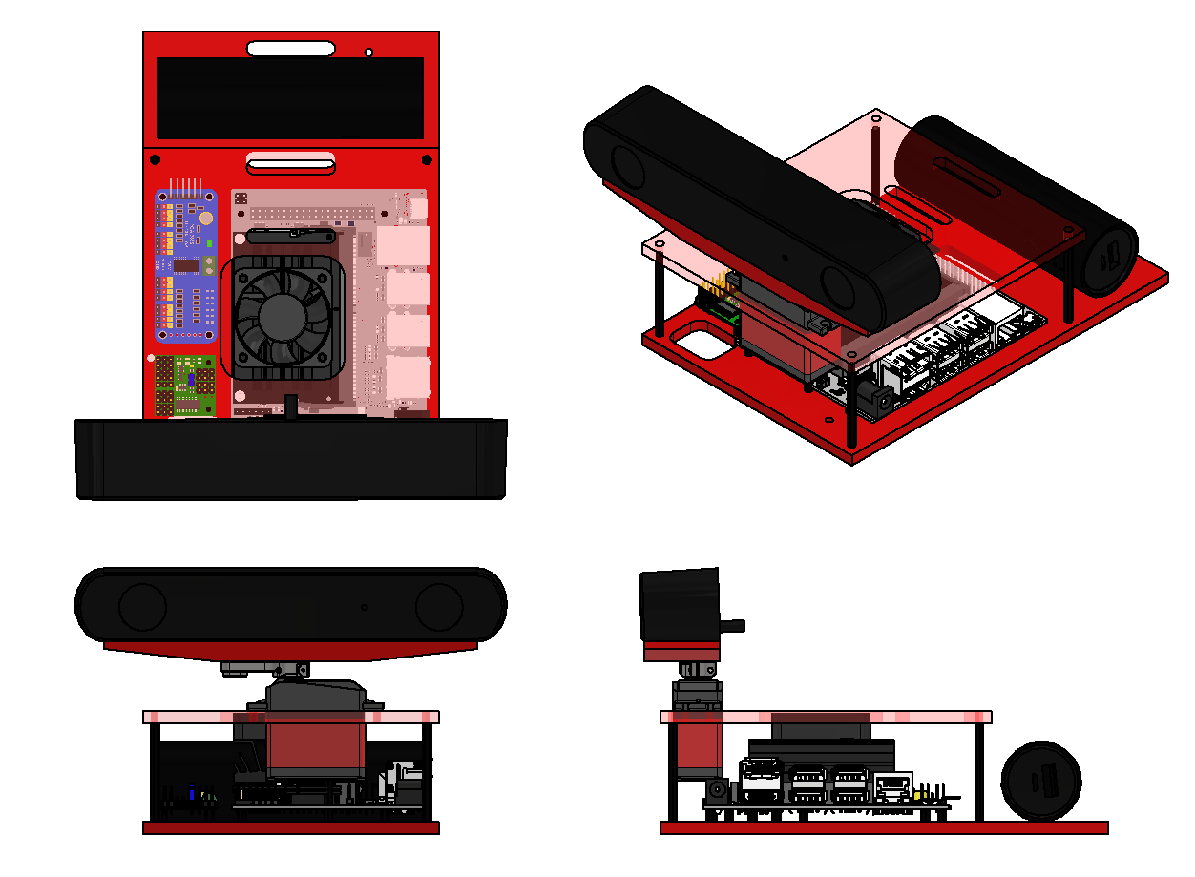

Figure 7: Car CAD Assembly

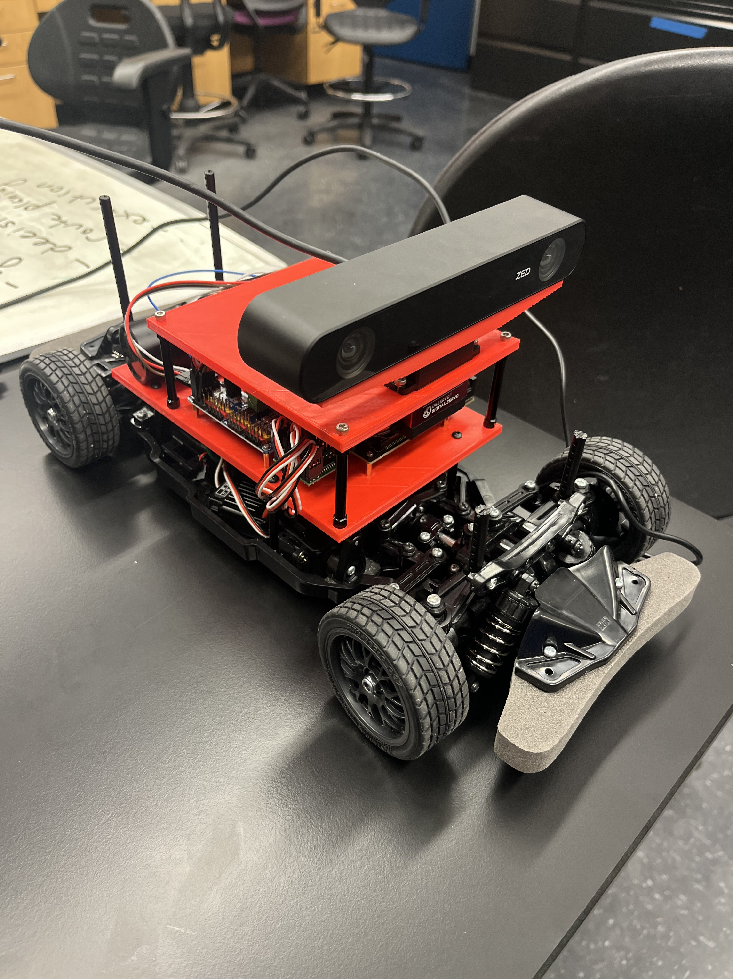

Figure 8: Assembled Car

# Design Procedure/Methods

While the major design requirement was integrating a new sensor, we tested the current suite for comparison later. Setting up a ROS environment became a priority for easier sensor integration and communication between new processes. The previous years used YOLOv7 on Ubuntu 18.04, therefore, we elected to set up ROS Melodic. We developed a navigation package that produced encouraging results in combination with the old CV model and CSI camera. The object detection bounding box error was published on a custom nav_msg to a servo proportional controller for the object following. We tested this system by moving the soccer ball back and forth and storing the angles sent to the front wheels in a text file. The results from this test are depicted in Figure 9. The resulting graph demonstrates the JetRacer’s ability to both detect and determine the correct angle with promising accuracy and can be used as a comparison for testing the new sensor.

Figure 9: CV Ball Tracking Steering Angle

We conducted a trade study to weigh the pros and cons of different sensors to integrate into the existing suite. Among the four tested: 2D LiDAR, 1D LiDAR, Ultrasonic, and ZED2 stereo camera, we concluded the ZED2 to be the best choice for our project.

Figure 10: Pugh Matrix

The results from 2D LiDAR testing using the YDLIDAR X2 are shown in Figures 11-13. We used the YDLIDAR SDK to plot the point cloud generated from observing the room and tested its application in Hector SLAM. Due to mounting restrictions on the car, this sensor would be at least 6 inches off the ground, too high to see the ball or other cars. This means the sensor would only be used for localization within the soccer environment, and without odometry (motor encoders), it would be very imprecise for an object in motion. The biggest benefit of this sensor was cost, as the ENGINE lab already had four in stock.

Figure 11 – 13: LiDAR Testing

As we tested the 1D LiDAR and Ultrasonic sensors with the CSI camera, we quickly realized they lacked accuracy and mounting options were structurally flimsy. Additionally, for complex navigation multiple distance measurements need to take place simultaneously. The sensor fusion required between the object detection and 1D measurement would be complicated and lack robustness.

Finally, we tested the ZED2 AI stereo camera. We initially borrowed this sensor from an RSO, which allowed us to determine its technical viability without the need to purchase one. As we began testing the ZED2 camera, we quickly found that the range capabilities, object detection, position tracking, and ROS wrapper surpassed the criteria for our new sensor. Having these capabilities built-in would mean our integration process would run much smoother. For testing, we attached it to the camera servo (Figure 15) and demonstrated object tracking with the COCO dataset and found it operated far better than the old camera. The downsides with the camera are cost ($449 per) and only estimated distance data using the stereo cameras. We concluded that this sensor would be our only major purchase, meaning it was something we could afford. Additionally, we tested the estimated depth sensing (Figure 16) and concluded it was good enough for our applications.

Figure 14: ZED2 AI stereo camera

Figure 15: ZED2 servo mount

Figure 16: ZED2 depth sensing testing

For ease of integration, accuracy, range, car position data, ball position data, and reliability the ZED2's performance surpasses the others, becoming our new sensor choice. This decision introduced a cascade of compatibility issues, heavily affecting the trajectory of the design process. The ZED2 operates using YOLOv8 and Ubuntu 20.04, meaning the Jetson Nano OS would need to be upgraded and our previous ROS package migrated to Noetic. Preliminary testing with the ZED2 camera has already produced promising results, and the team has been able to implement ball following with the ZED and camera servo. The team is optimistic about the ability to fully implement the ZED2 on the JetRacer car.

# Test Design

While soccer performance is qualitative, individual subsystems can undergo testing and measurement. For testing, these subsystems can be categorized as ZED2 and system capabilities.

We will test ZED2 object detection certainty and reliability for classified objects within our soccer field environment at different distances and for partially obscured objects. Additionally, we will test the depth sensing capability by comparing measurements to known distances. This will result in a resolution versus distance plot like Figure 17 for our specific dataset and environment.

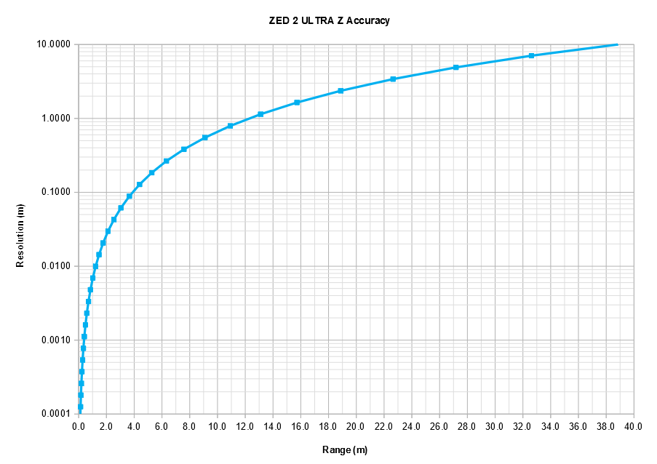

Figure 17: ZED2 Stock Resolution Verses Distance

For system capabilities, we will test for latency through systems. Additionally, for Servo PID testing, we can save bounding box errors in a text file as the servo tracks the soccer ball. As we move the ball, we can plot these values to ensure a smooth impulse response. Especially without Unity integration, strategy, and path planning are pre-determined. To test pathing, we will lay out objects at precise locations to compare expected versus actual movement. Additionally, the ZED2's measured position tracking within the generated spatial map can be compared to the expected route the navigation package sets.

Our initial testing objective is to strike a ball into an open goal along a calculated trajectory. Subsequentially, we will advance capabilities for both 1v1 and 2v2 soccer with offense/defense and collaboration.

# Realistic Constraints/Relevant Engineering Standards

The realistic constraints for this project are bound to the limitations of the NVIDIA JetRacer cars and the ZED2 stereo camera. The car's limited steering radius (60 degrees), lack of motor encoders, and wheel drift will play a role in deviating between expected versus actual movement. Additionally, the car's power sources are constrained. The Jetson Nano is powered by a 5V power bank and the motors by a NiMH 7.2V battery pack. Especially with ZED2 integration, the car's approximate battery life is 30 minutes.

The capabilities of the ZED2 include the reliability of object detection and distance measurement. Especially for objects at a distance or partially obstructed, the ZED2 might provide unreliable measurements. The ZED2 interfaces with the Jetson Nano which has limited computing capabilities. Upgrading to the Jetson Orin Nano would provide better performance, but conflicts with budget restrictions.

As far as we know, our project is not subject to any industry engineering standards. We are only required to make deliverables and comply with rules given by our company sponsor.

# Project Resources/Budget

## Cost Breakdown

* Field: $98.63 (Requires Reimbursement)
* ZED2: $449
* PLA Filament: $25
* Hex Standoffs: $13
* Miscellaneous: ~$100

Our total allocated budget for the project is $3500. In the winter quarter, we purchased one ZED2, field supplies, two spools of 1.75mm PLA filament, and two M2 hex standoff kits, totaling $623.63 before tax.

For the spring quarter, we expect to purchase three more ZED2 cameras, totaling $1350 before tax. We predict around $100 for miscellaneous costs, therefore, our total expected spending will be $2100. Additionally, if we determine the necessity of upgrading to the Jetson Orin Nano, we will need to negotiate with the industry sponsor and ENGINE program to increase our budget to accommodate the $2000 purchase.

# Industry Sponsor Comments

The Jet Racer team has done an excellent job in the winter quarter advancing the Jet Racer Soccer League project. The team has created realistic goals, established a schedule to meet these goals, and executed on the technical tasks to achieve progress. The weekly meetings between the student team and the industry sponsor team have been productive and informative for both sides. The team has communicated status and asked specific questions to overcome technical challenges and requirement clarification. They have arrived on a sensor upgrade that looks very promising to enhance the capabilities of the car.

Looking forward to the spring quarter, the team will face a number of challenges to put their design into practice. Previous years have struggled in this phase to execute and overcome the technical challenges that arise during integration and test, however the team has already demonstrated efficient preliminary testing of the various potential sensor upgrades. We have laid out high level success criteria for the project but I believe it will be helpful to the team to zoom in and identify detailed success criteria for individual tests, e.g. the car will make contact with the ball at a 60% success rate for initial testing. The application of a Unity model to improve soccer strategy has also been a challenge in years past due to the complex dynamic environment and resource limitations, so I recommend setting realistic goals here in this area to achieve incremental progress while still executing on the other parts of the project – sensor upgrade, basic soccer playing, etc.

Overall, this is a strong engineering team that has demonstrated good engineering practices through both sides of the Systems Engineering “V”. I look forward to this spring semester and what they will be able to achieve.

# Success Criteria

1. The project is completed by May 28, 2024.
2. The project is completed within the given budget, $3500.
3. The project fulfills the scope given beforehand:
   1. Build and enhance four JetRacer cars that will compete in a soccer environment.
   2. Design and use a simple soccer field for the vehicles to compete within which is reusable and may be transported.
   3. Demonstrate existing capabilities and limitations.
   4. Integrate the new sensor suite to improve the RC car capabilities and situational awareness.
   5. Identify objects while competing (such as a wall, ball, teammate, goal, and foe).
   6. Identify and work cooperatively with allies to score.
   7. Identify and work against foes who are trying to score against you.
4. The results of the project are functional.
5. The team gains experience and is satisfied with the project results.
6. The project is documented so it can be helpful in the future.